|  |  |
| --- | --- |
| **Experiment** | **Without Adaptation** |
| A2019 -> A2019 | **Acc**=94.8%, **kappa**=91.9%, **AvgF1**=94%,  **Per-class F1**: [0.899, 0.969, 0.952] |
| A2019 -> A2020 | **Acc**=81.5%, **kappa**=66.6%, **AvgF1**=78.7%,  **Per-class F1**: [0.879, 0.864, 0.618] |
| A2019 -> A2021 | **Acc**=86%, **kappa**=77.9%, **AvgF1**=85.7%,  **Per-class F1**: [0.870, 0.897, 0.804] |
| A2019 -> B2019 | **Acc**=50.8%, **kappa**=19.6%, **AvgF1**=46.4%,  **Per-class F1**: [0.523, 0.301, 0.568] |
| A2019 -> B2020 | **Acc**=50.8%, **kappa**=19.1%, **AvgF1**=44.2%,  **Per-class F1**: [0.443, 0.236, 0.647] |
| A2019 -> B2021 | **Acc**=47.7%, **kappa**=17.3%, **AvgF1**=43%,  **Per-class F1**: [0.427, 0.243, 0.618] |
| A2019 -> C2019 | **Acc**=62.7%, **kappa**=26.7%, **AvgF1**=44.3%,  **Per-class F1**: [0.737, 0.367, 0.554] |
| A2019 -> C2020 | **Acc**=59.4%, **kappa**=26.3%, **AvgF1**=42.5%,  **Per-class F1**: [0.704, 0.015, 0.556] |
| A2019 -> C2021 | **Acc**=45.1%, **kappa**=0.08%, **AvgF1**=29.7%,  **Per-class F1**: [0.577, 0.0009, 0.314] |

**A2019 -> A2019**

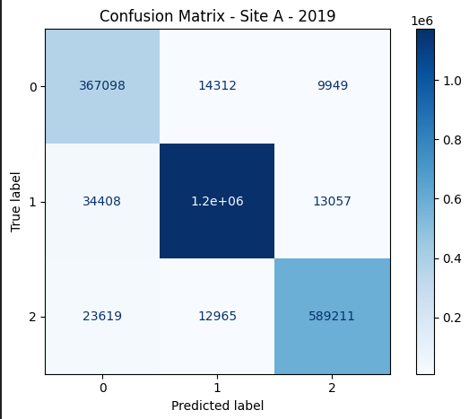

**A2019 -> A2020**

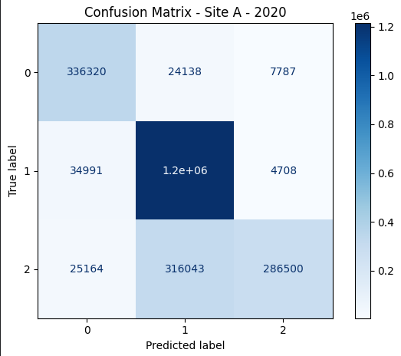

**A2019 -> A2021**

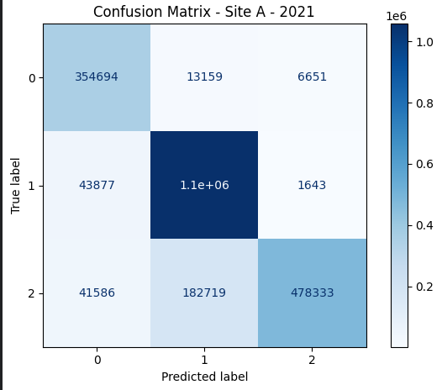

**A2019 -> B2019**

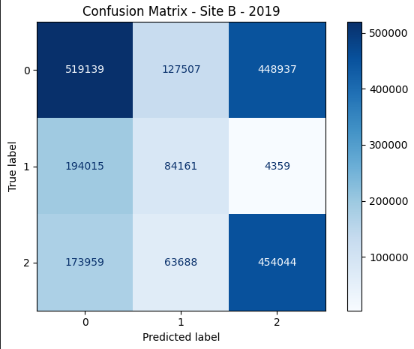

**A2019 -> B2020**

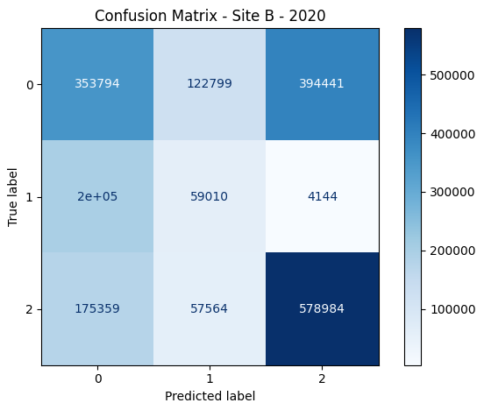

**A2019 -> B2021**

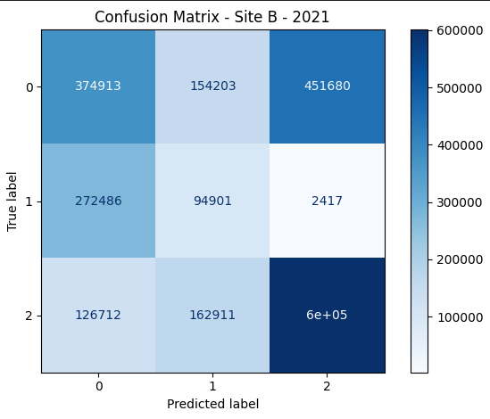

**A2019 -> C2019**

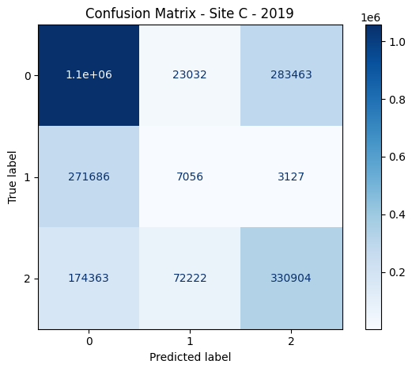

**A2019 -> C2020**

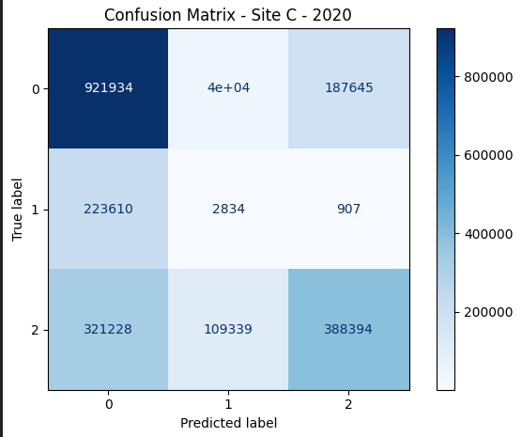

**A2019 -> C2021**

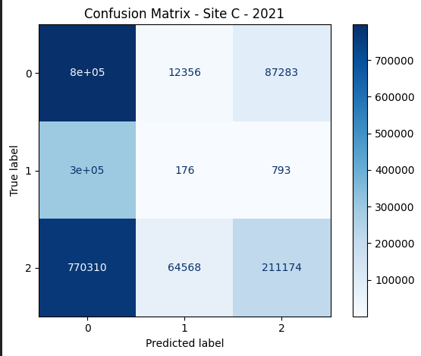

**Evaluation in Deterministic Way**

